

**face recognition**

**Harsh Dubey-11801795 -41**

**Manushi Khanna-11805605-42**

**Sakshi Nischal-11805797-44**

**Akshat Jain-11802600-47**

**Submitted to – Dr. Rahul Sir**

ABSTRACT

The face is one of the easiest ways to distinguish the individual identity of each other. Face recognition is a personal identification system that uses personal characteristics of a person to identify the person's identity. Human face recognition procedure basically consists of two phases, namely face detection, where this process takes place very rapidly in humans, except under conditions where the object is located at a short distance away, the next is the introduction, which recognize a face as individuals. Stage is then replicated and developed as a model for facial image recognition (face recognition) is one of the much-studied biometrics technology and developed by experts. Face Recognition represents one of the attractive research areas. It has drawn the attention of many researchers due to its varying applications such as security, healthcare, marketing, identity authentication, surveillance etc. In this order, different face recognition algorithms have been proposed however, one algorithm that stands out in the event of limited dataset is one shot learning. “One shot” means learning from a single training item.

LITERATURE REVIEW

Face discovery is a PC innovation that decides the area and size of human face in subjective picture. The facial highlights are identified and some other articles like trees, structures and bodies and so forth are disregarded from the advanced picture. It tends to be viewed as a specific case of article class identification, where the assignment is finding the area and sizes of all items in a picture that have a place with a given class. Face discovery, can be viewed as a more general instance of face limitation. In face limitation, the assignment is to discover the areas and sizes of a known number of faces. Essentially there are two sorts of ways to deal with recognize facial part in the given picture for example highlight base and picture base approach. Feature base methodology attempts to extricate highlights of the picture and match it against the information on the face highlights. While picture base methodology attempts to get best match among preparing and testing pictures.

**Various techniques: -**

* **Eigen Faces:** Eigen faces is a way to deal with facial acknowledgment dependent on the general appearance of a face, not on its specific subtleties. By methods for system that can capture and reshape the change present in the picture, the reshaped data is dealt with like the DNA of a face, consequently permitting recuperation of comparative countenances (since they have comparative fluctuations) in a large group of facial pictures.
* **Neural Networks:** A neural system is either a framework programming or equipment that works like the undertakings performed by neurons of human mind. Neural systems incorporate different advances like profound learning, and AI as a piece of Artificial Intelligence (AI).
* **Graph Matching:** Graph Matching has applications in stream systems, booking and arranging, displaying bonds in science, diagram shading, the steady marriage issue, neural systems in man-made reasoning and that's only the tip of the iceberg. Many diagram coordinating calculations exist so as to streamline for the parameters fundamental directed by the current issue.
* **Geometrical Feature Matching:** Geometric feature based edge-coordinating methodology is one such strategy which is applied to coordinate form line information from photogrammetric model. Since each kind of topographical component has natural geometric highlights spoke to by the geometric information (organizes). This information prepared ought to exhibit their geometric highlights.
* **Template Matching:** Template Matching is a significant theme in the field of Artificial Intelligence (AI) as it is one of the ways to deal with the fundamental issue of picture preparing which is finding the area of intrigue.

INTRODUCTION

A Facial Recognition System is an innovation equipped for distinguishing or confirming an individual from a computerized picture or a video outline from a video source. There are different techniques in which facial acknowledgment frameworks work, yet all in all, they work by looking at chosen facial highlights from given picture with faces inside a database. It is additionally portrayed as a Biometric Artificial Intelligence based application that can particularly distinguish an individual by investigating designs dependent on the individual's facial surfaces and shape. While at first a type of PC application, it has seen more extensive uses lately on portable stages and in different types of innovation, for example, apply autonomy. It is commonly utilized as access control in security frameworks and can be contrasted with different biometrics, for example, unique mark or eye iris acknowledgment frameworks. In spite of the fact that the precision of facial acknowledgment framework as a biometric innovation is lower than iris acknowledgment and unique mark acknowledgment, it is broadly embraced because of its contactless and non-intrusive procedure. As of late, it has likewise gotten well known as a business ID and advertising apparatus. Different applications incorporate propelled human-PC collaboration, video observation, programmed ordering of pictures, and video database, among others.

**FACIAL RECOGNITION APPLICATIONS**

In light of our appraisal of the applications in the field today, the lion's share of facial acknowledgment use-cases seem to fall into three significant classifications:

* Security: Companies are preparing profound learning calculations to perceive misrepresentation recognition, lessen the requirement for customary passwords, and to improve the capacity to recognize a human face and a photo.
* Healthcare: Machine learning is being joined with PC vision to all the more precisely track quiet medicine utilization and bolster torment the executives’ methodology.
* Marketing: Fraught with moral contemplations, advertising is a thriving area of facial acknowledgment development, and it's one we can hope to see a greater amount of as facial acknowledgment gets universal.
* Hospitality: The cordiality division is one of the most serious ventures on the planet. Each bit of leeway whether huge or little has any kind of effect to the players inside it. By Applications of Facial Recognition innovation, the potential outcomes are inestimable. Lodgings can record client inclinations, give better security and mechanize registration and check outs. The decrease of human blunder carries a streamlined way to deal with commonplace client assistance undertakings that don't require a pinch of mankind.

## ****ADVANTAGES OF FACIAL RECOGNITION SYSTEM****

**• Security Through Biometric Authentication:** One of the advantages of facial acknowledgment framework focuses on its application in biometrics. It very well may be utilized as a piece of recognizable proof and access control frameworks in associations, just as close to home gadgets, for example, on account of cell phones.

**• Automated Image Recognition:** The framework can likewise be utilized to empower robotized picture acknowledgment abilities. Consider Facebook for instance. Through AI and Big Data examination, the person to person communication site can perceive photographs of its clients and permit robotized connecting or labeling to singular client profile.

**• Deployment in Security Measures:** Like biometric application and computerized picture acknowledgment, another preferred position of facial acknowledgment framework includes its application in law requirement and security frameworks. Computerized biometric character permits less nosy checking and mass recognizable proof.

**• Human-Computer Interaction:** The system also supports [virtual reality](https://www.profolus.com/topics/types-and-methods-of-virtual-reality-systems/) and [augmented reality](https://www.profolus.com/topics/advantages-and-disadvantages-of-augmented-reality/) applications. Filters in Snapchat and Instagram use both AR and facial recognition. It is also worth noting that equipping devices with facial recognition capabilities means expanding their capabilities. For example, iPhone devices from [Apple](https://www.profolus.com/topics/business-strategy-of-apple-concise-analysis/) use Face ID for biometric identification and supporting its AR capabilities.

## ****DISADVANTAGES OF FACIAL RECOGNITION SYSTEM****

**• Issues About Reliability and Efficiency:** A prominent inconvenience of facial acknowledgment framework is that it is less dependable and proficient than other biometric frameworks, for example, unique mark. Factors, for example, light, articulation, and picture or video quality, just as programming and equipment abilities, can influence the exhibition of the framework.

**• Further Reports About It Reliability:** A few reports have called attention to the incapability of certain frameworks. For instance, a report by a backing association noticed that the frameworks utilized by law authorization offices in the U.K. had an exactness pace of just 2 percent. Applications in London and Tampa, Florida didn't bring about better law requirement as per another report.

**• Concerns About Racial Bias:** An investigation by the American Civil Liberties Union uncovered that the Recognition innovation created by Amazon bombed almost 40 percent bogus matches in tests including minorities. When all is said in done, the framework has been scrutinized for propagating racial inclination because of bogus matches.

**• Issues with Privacy Laws:** Alleged clash with security rights is another impediment of facial acknowledgment. In Illinois, for instance, its Biometric Information Privacy Act requires confirmed agree for organizations to gather biometric information. The way that the framework empowers less meddlesome mass recognizable proof additionally means mass observation, which as indicated by gatherings, is an infringement of protection rights.

## USING A PRE-TRAINED NEURAL NETWORK FOR FACE RECOGNITION

We will utilize OpenFace, which is an open face profound learning facial acknowledgment model. It depends on the paper: FaceNet: A Unified Embedding for Face Recognition and Clustering by Florian Schroff, Dmitry Kalenichenko, and James Philbin at Google. OpenFace is actualized utilizing Python and Torch which permits the system to be executed on a CPU or with CUDA.

We needed to actualize the application in Keras (using Tensorflow backend), and to do that I have utilized a pre-prepared model known as Keras-OpenFace by Victor Sy Wangwhich is an open source Keras usage of the OpenFace.

Presently we should comprehend what has been done to make above face acknowledgment application.

Fundamentally, I have utilized Keras-OpenFace pre-prepared model for taking care of the face pictures to create 128 measurements installing vector. I accept that the perusers know about profound learning and how Convolutional Neural Network (CNN) works.

## ONE SHOT LEARNING

In one shot learning, just one picture for each individual is put away in the database, which is gone through the neural system to create an inserting vector. This implanting vector is contrasted and the vector produced for the individual who must be perceived. On the off chance that there exist likenesses between the two vectors, at that point the framework perceives that individual, else that individual isn't there in the database. This can be comprehended by the underneath picture.

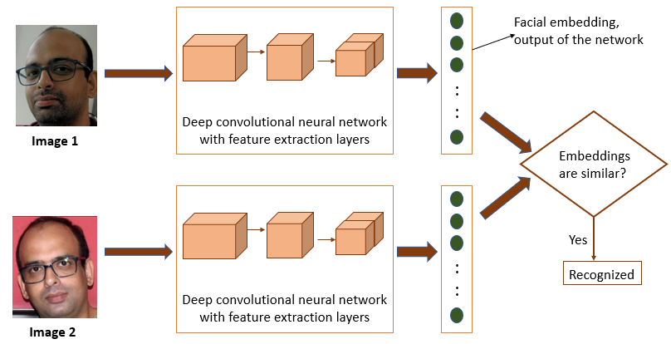

## HOW DOES A NEURAL NETWORK LEARN (TRIPLET LOSS FUNCTION) FACE RECOGNITION?

Here we are utilizing OpenFace pre-prepared model for facial acknowledgment. Without going into much subtleties on how this neural system recognizes two same faces, suppose that the model is prepared on a huge arrangement of face information with a misfortune work which bunches indistinguishable pictures together and separate non-indistinguishable faces from one another. It is otherwise called a triplet misfortune work.

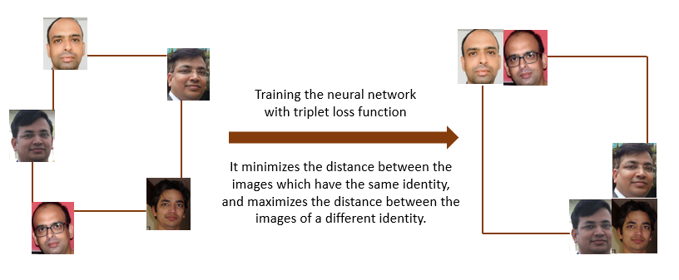

It is additionally essential to realize that while preparing the neural system, we require numerous pictures of a similar individual for streamlining the triplet misfortune work. Subsequently, preparing a neural system for face acknowledgment is certifiably not a one-shot learning task.

## Understanding the basic design

We should envision how to make essential facial acknowledgment application utilizing a pre-prepared profound neural system. Preparing of the system has just been done as appeared in the beneath outline.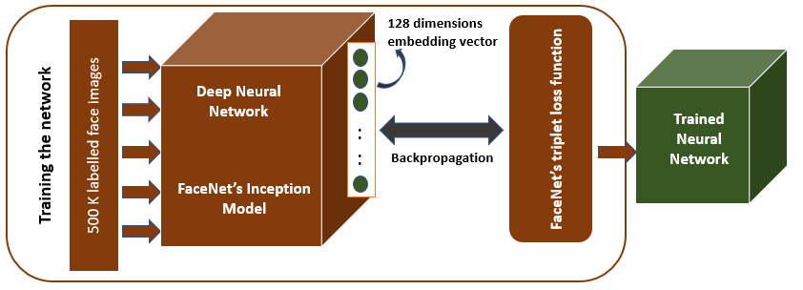

OpenFace’s training module

We are utilizing this pre-prepared system to look at the implanting vectors of the pictures put away in the record framework with the installing vector of the picture caught from the webcam. This can be clarified by the beneath outline.

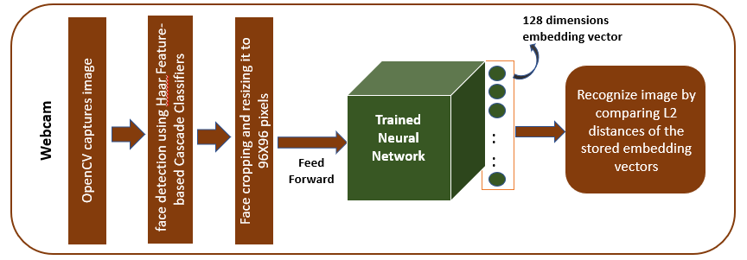

As per the above diagram, if the face captured by webcam has similar 128-bit embedding vector stored in the database then it can recognize the person. All the images stored in the file system are converted to a dictionary with names as key and embedding vectors as value.

When processing an image, face detection is done to find bounding boxes around faces. I have used [**OpenCV’s Hear feature-based Cascade Classifiers**](https://docs.opencv.org/3.4/d7/d8b/tutorial_py_face_detection.html)for extracting the face area. Before passing the image to the neural network, it is resized to 96x96 pixels as the deep neural network expects the fixed (96x96) input image size.

## Calculating the similarity between two images

To analyse two pictures for closeness, we process the separation between their embedding. This should be possible by either ascertaining Euclidean(L2) separation or Cosine separation between the 128-dimensional vectors. On the off chance that the separation is not exactly an edge (which is a hyperparameter), at that point the countenances in the two pictures are of a similar individual, if not, they are two unique people.

We utilized Affine Transformation to improve Train Test Image.

CONCLUSION

The computational models, which were executed right now, picked after broad research, and the fruitful testing results affirm that the decisions made by the specialist were dependable. This framework was tried under strong conditions right now and it is visualized that true execution will be undeniably increasingly precise. The completely computerized frontal view face discovery framework showed practically immaculate exactness and in the scientist's assessment further work need not be led right now. The completely computerized face identification and acknowledgment framework was not vigorous enough to accomplish a high acknowledgment exactness. The main explanation behind this was the face acknowledgment subsystem didn't show even a slight level of invariance to scale, turn or move mistakes of the divided face picture. Be that as it may, if a further handling, was actualized to additionally standardize the sectioned face picture, execution will increment to levels similar to the manual face discovery and acknowledgment framework. All other actualized frameworks showed estimable outcomes and consider well the deformable format and Principal Component Analysis procedures. The most appropriate certifiable applications for face identification and acknowledgment frameworks are for mugshot coordinating and observation. There are better strategies, for example, iris or retina acknowledgment and face acknowledgment utilizing the warm range for client access and client confirmation applications since these need an extremely high level of precision. The continuous mechanized posture invariant face identification and acknowledgment framework proposed in part seven would be perfect for swarm reconnaissance applications. On the off chance that such a framework were broadly actualized its potential for finding and following suspects for law implementation organizations is enormous. The actualized completely mechanized face location and acknowledgment framework (with an eye identification framework) could be utilized for basic observation applications, for example, ATM client security, while the executed manual face discovery and robotized acknowledgment framework is perfect of mugshot coordinating. Since controlled conditions are available when mugshots are accumulated, the frontal view face acknowledgment plan should show an acknowledgment exactness much better than the outcomes, which were acquired right now, was led under unfavourable conditions.